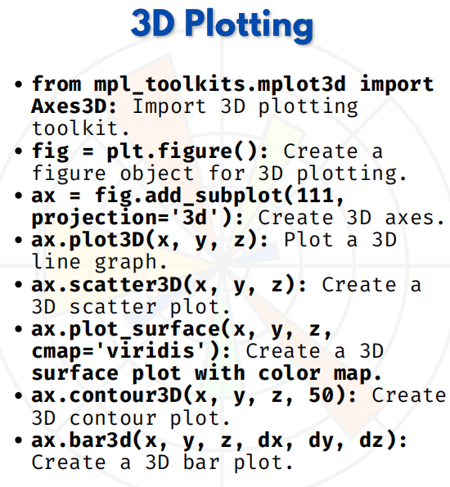

MULTIPLE PLOTS

1. plt.plot(x, y) → Create a basic plot
import matplotlib.pyplot as plt
x = [1, 2, 3, 4]
y = [2, 4, 6, 8]
plt.plot(x, y)
plt.title("Basic Plot")
plt.show()

2. plt.subplot(1, 2, 1) → Create subplots in a single row, first plot
x = [1, 2, 3, 4]
y = [2, 4, 6, 8]
plt.subplot(1, 2, 1) # 1 row, 2 columns, 1st plot
plt.plot(x, y)
plt.title("First Plot")

3. plt.subplot(1, 2, 2) → Create subplots in a single row, second plot
z = [1, 4, 9, 16]
plt.subplot(1, 2, 2) # 1 row, 2 columns, 2nd plot
plt.plot(x, z)
plt.title("Second Plot")
plt.show()

4. plt.subplots(2, 2) → Create a 2x2 grid of subplots
fig, axs = plt.subplots(2, 2)
axs[0, 0].plot(x, y)
axs[0, 0].set_title("Top Left")
axs[0, 1].plot(x, z)
axs[0, 1].set_title("Top Right")
axs[1, 0].plot(y, z)
axs[1, 0].set_title("Bottom Left")
axs[1, 1].plot(z, y)
axs[1, 1].set_title("Bottom Right")
plt.show()

5. ax1.plot(x, y), ax2.plot(x, z) → Plot on different axes in subplots
fig, (ax1, ax2) = plt.subplots(1, 2)
ax1.plot(x, y)
ax1.set_title("Plot 1")
ax2.plot(x, z)
ax2.set_title("Plot 2")
plt.show()

6. fig.tight_layout() → Adjust layout of multiple subplots automatically
fig, axs = plt.subplots(2, 2)
axs[0, 0].plot(x, y)
axs[0, 1].plot(x, z)
axs[1, 0].plot(y, z)
axs[1, 1].plot(z, y)
fig.tight_layout() # Fixes overlapping titles/labels
plt.show()

7. plt.subplots_adjust(left, right, top, bottom) → Customize spacing between subplots
fig, axs = plt.subplots(1, 2)
axs[0].plot(x, y)
axs[1].plot(x, z)
plt.subplots_adjust(left=0.1, right=0.9, top=0.9, bottom=0.2, wspace=0.4)
plt.show()

8. plt.subplot(111) → Create a single full-sized plot
plt.subplot(111) # 1 row, 1 column, 1 plot
plt.plot(x, y)
plt.title("Full Size Plot")
plt.show()

